Activity 03  | P1 | P2 | P3 | P4 | P5 | P6

# **Activity 03:**

**Iteration**

**Explore Iteration (**Loop Control**)** using

Sample projects with processes requiring repetition or looping

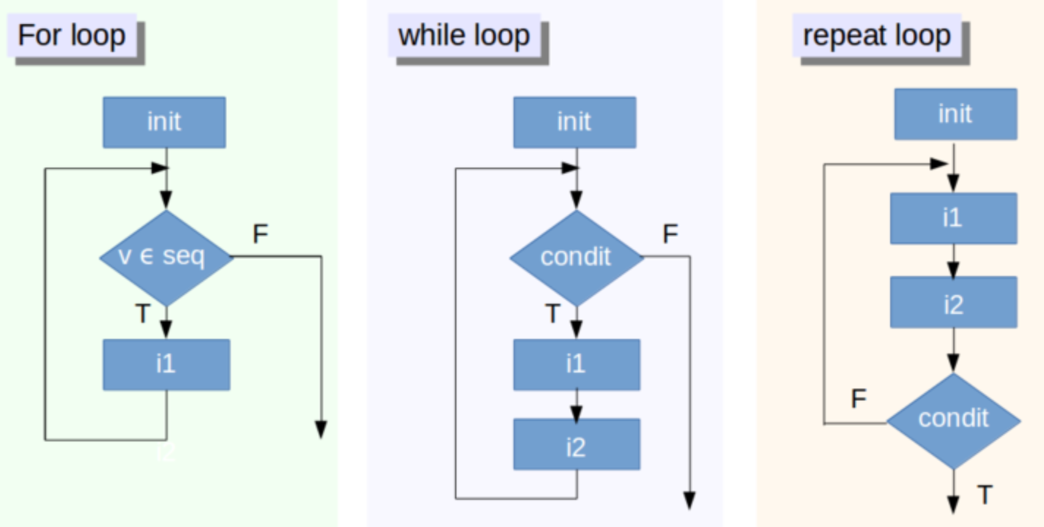

Use your school **OneDrive** store your Digital Solutions work.  
Naming Convention required = **DS_Surname_FirstName_ID**

**Eg DS_Mathews_Mike_0123456**

Save this file to that Folder as **“Activity03.docx”**

Note: you will also save the python files (x6)

eg **Act03_proj1**.py ( + Act03_proj2….…proj6 )

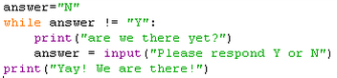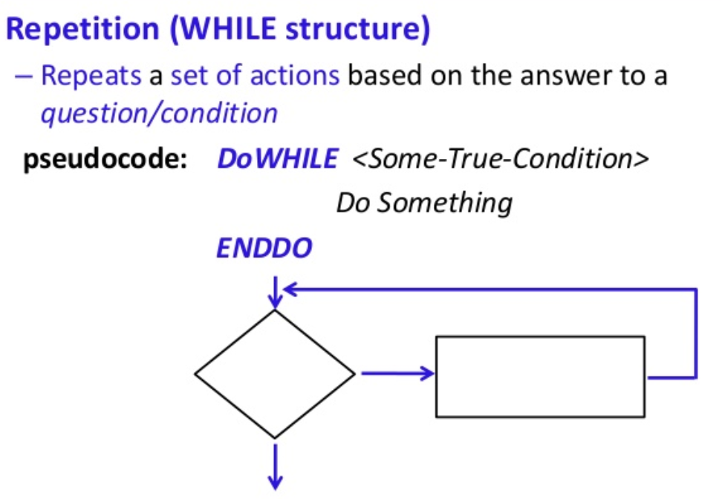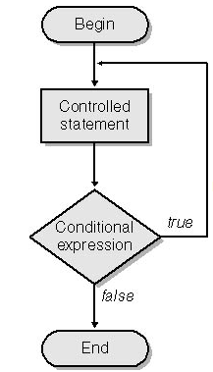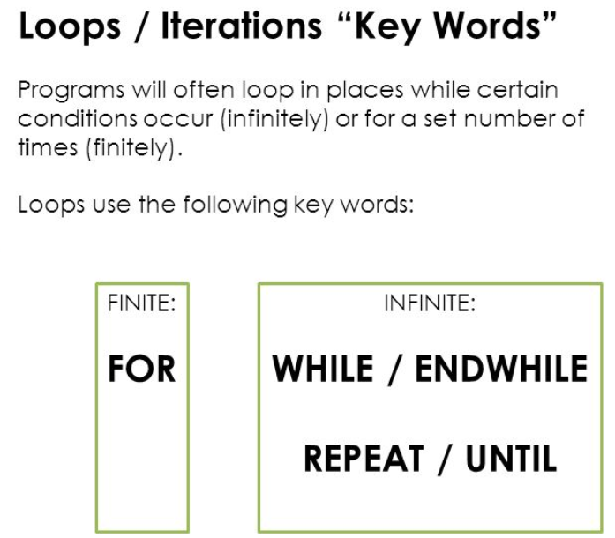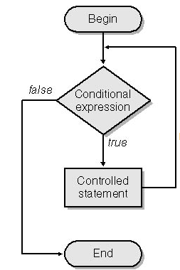

**Sample loops**

Activity 03  | P1 | P2 | P3 | P4 | P5 | P6

# **Project 1**

|  |
| --- |
| Suggest a integer for times tables : 4  Here is the 4 times tables for **4**  4 x 1 = 4  4 x 2 = 8  4 x 3 = 12  4 x 4 = 16  4 x 5 = 20  4 x 6 = 24  4 x 7 = 28  4 x 8 = 32  ……….  4 x 12 = 48 |

Write a Python program that writes  
out **the first 12** times table **rows**

For a integer suggested the user

Sample **output** should

look like this:

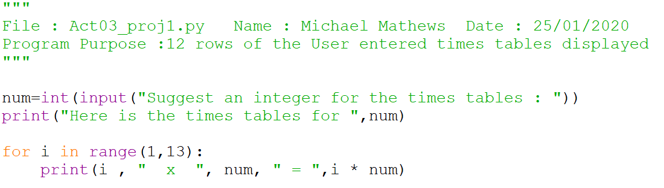

Activity 03  | P1 | P2 | P3 | P4 | P5 | P6

# **Project 2**

|  |
| --- |
| Welcome to the Loan Calculator  Enter the amount to be borrowed $ 1000  Weekly payment $ 19.23  Monthly payment $ 83.33  $ 1000.00 - Month 1  $ 916.67 - Month 2  $ 833.33 - Month 3  $ 750.00 - Month 4  $ 666.67 - Month 5  $ 583.33 - Month 6  $ 500.00 - Month 7  $ 416.67 - Month 8  $ 333.33 - Month 9  $ 250.00 - Month 10  $ 166.67 - Month 11  $ 83.33 - Month 12 |

Write a Python program that

will calculate **Weekly**

& **Monthly payments**

required to pay off a loan.

Plus Show the loan balance

for months 1-12.

Assume no interest charged

on this one Year loan (52wks)

Sample **output** should

look like this:

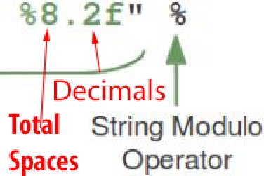

[Tips for formatting output](https://www.python-course.eu/python3_formatted_output.php)

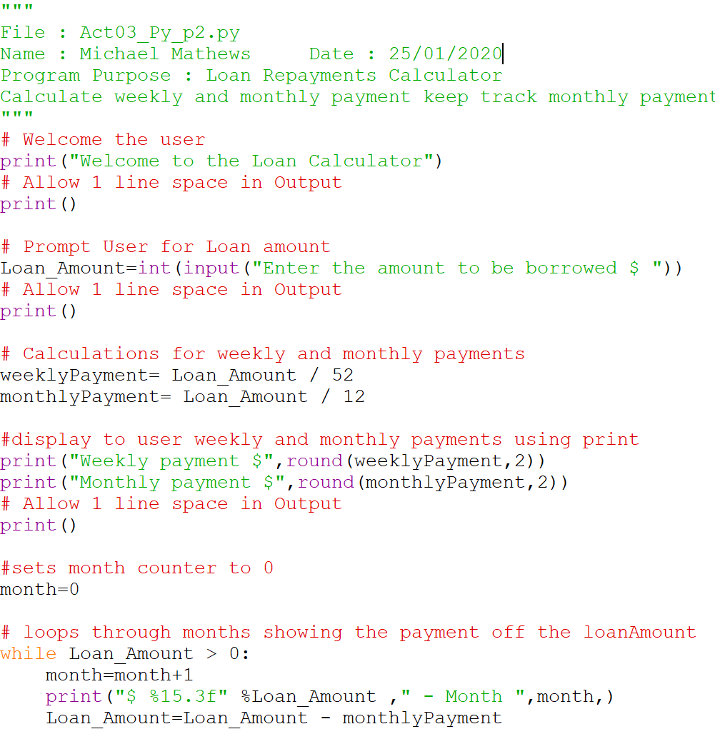

Activity 03  | P1 | P2 | P3 | P4 | P5 | P6

# **Project 3**

|  |
| --- |
| 1 - is a prime number  2 - is a prime number  3 - is a prime number  4 equals 2 * 2  5 - is a prime number  6 equals 2 * 3  7 - is a prime number  8 equals 2 * 4  9 equals 3 * 3  10 equals 2 * 5  11 - is a prime number  12 equals 2 * 6  13 - is a prime number  14 equals 2 * 7  15 equals 3 * 5  16 equals 2 * 8  17 - is a prime number  18 equals 2 * 9  19 - is a prime number |

Write a Python program that prints

the prime numbers up to 20

Note that prime numbers

have only two factors

(1 and itself)

Hence to check if there are

factors we can use

20 % 4 = **0** (is a factor)

13 % 6 = **1** (is not a factor)

13 % 5 = **3** (is not a factor)

13 % 4 = **1** (is not a factor)

13 % 3 = **1** (is not a factor)

ie num % Factor = 0   
(remainder means it is a factor)

Sample **output** should

look like this:

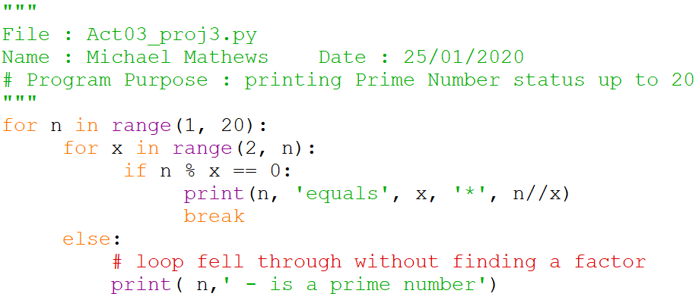

Activity 03  | P1 | P2 | P3 | P4 | P5 | P6

# **Project 4**

|  |
| --- |
| Input some integers to  calculate their sum and average  Press Enter after each input value  and 0 to Finish.  Input some numbers  66  99  33  44  0  Sum of the numbers = 242.0  Average of the numbers = 60.5 |

Write a new Python program that

allows users to input number values

and use a Zero 0 to finish.

Then Output Sum and Average

Sample **output** should

look like this:

(Sample data 66 99 33 44 0)

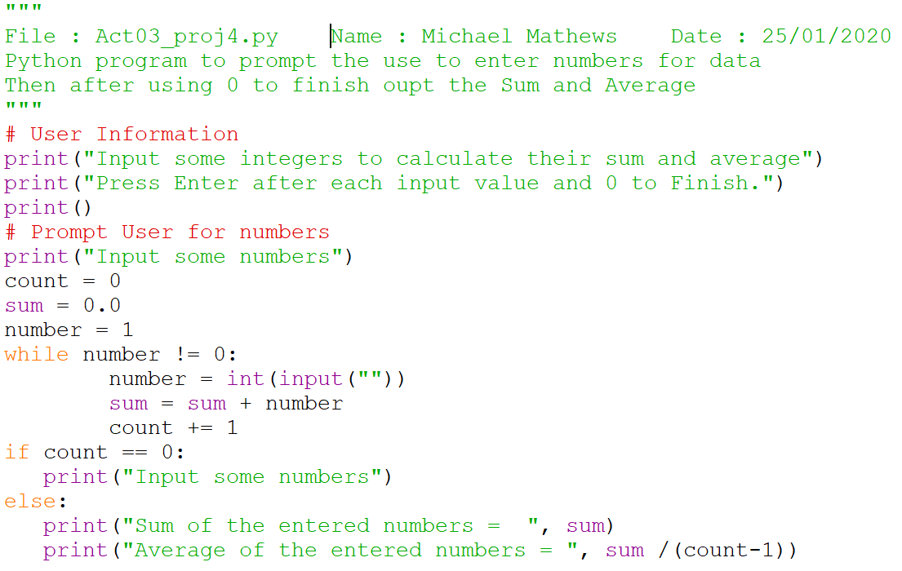

Activity 03  | P1 | P2 | P3 | P4 | P5 | P6

# **Project 5**

|  |
| --- |
| What is the Ceiling for numbers :10  Here are the Square and Cubic numbers up to 7  square cube  1 1  4 8  9 27  16 64  25 125  36 216  49 343 |

Write a Python program

to print **square** and **cubic** numbers

# Up to a user defined

Ceiling Number. (highest)

[Formatting Tips](https://pyformat.info/)

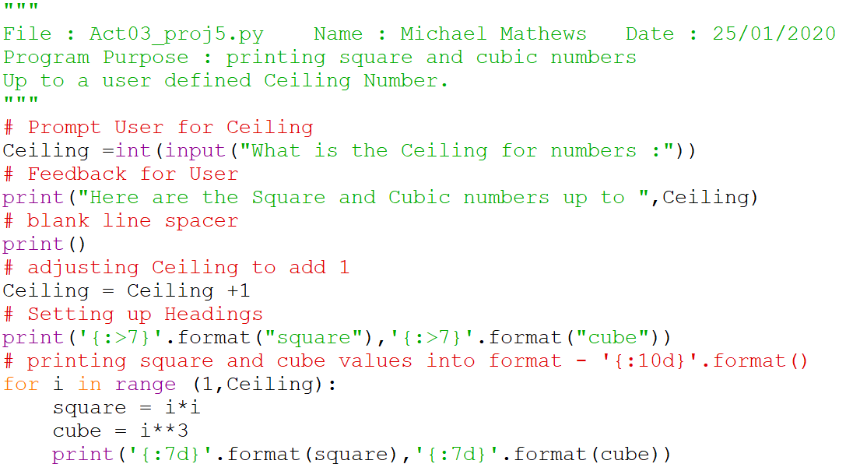

Activity 03  | P1 | P2 | P3 | P4 | P5 | P6

# **Project 6**

|  |
| --- |
| Enter a number: 30  The factors of 30 are:  1  2  3  5  6  10  15  30 |

Prompt user to suggest

the **number**

Write a program which

lists all the Factors

of the **number**.

